Name: Date:

Regents Earth Science Ms. Venuti

Unit 1 Study Guide

Topic 1: Formation of the Universe

1. What is the name of the theory for the creation of the universe?

2. What are the two pieces of evidence for this theory?

a.

b.

Topic 2: Shape of the Earth

1. What is the name of the shape of the Earth?

2. What are the four pieces of evidence for the shape of the Earth without leaving the Earth’s surface?

a.

b.

c.

d.

3. What is the best piece of evidence for the shape of Earth?

Topic 3: Density

1. Know how to round to the nearest tenth

1.99999 ➔ __________________, 2.38 ➔ ___________________, 66.71 ➔ _________________

2. What is density?

3. What is the formula for density?

4. What are the two methods for determining the volume of objects. Describe each of them.

a.

b.

5. Calculate the density: A student determines that the volume of an object to be 30mL and contain a mass of 15g, what is the object’s density?

6. Will the object from question 5 float in water? Why or why not?

Topic 4: Maps

1. What is Earth’s coordinate system?

2. Fill in the table below

|  |  |  |
| --- | --- | --- |
|  | Latitude | Longitude |
| Reference Lines |  | 1.  2. |
| Range |  |  |
| Unit for the line (N,S,E,W) |  |  |
| Side View |  |  |
| Polar View |  |  |

3. Determine the latitude and longitude for each of these locations (Degrees, Minutes, Unit)

Buffalo ___________________________________ Mt Marcy _____________________________________

Syracuse _______________________________________ Slide Mountain ______________________________

Riverhead _______________________________________ Watertown __________________________________

4. Using page 3 of the ESRT, determine two locations that have the same latitude.

5. Using page 3 of the ESRT, determine two locations that have the same longitude.

Topic 5: Time

1. How many time zones are there in the World?

2. Each time zone is how many degrees?

3. If you travel to the east, time gets earlier/later in the day. (Circle one)

4. If you travel to the west, time gets earlier/later in the day. (Circle one)

5. Time is determined by which type of lines of Earth’s coordinate system?

6. Two locations have the same time if they are on the same latitude/ longitude (Circle one)

Topic 6: Field Maps

1. What is a field?

2. What are isolines?

3. Describe the three types of isolines

a.

b.

c.

4. What is gradient?

5. How can you determine the gradient of a hill/mountain by looking at contour lines?

6. What is the equation for gradient?

7. When you are determining gradient what three things must be included as part of your answer?

a.

b.

c.

Topic 6: Topographic Maps/Topographic Profiles

1. What shape do contour lines make?

2. How do you determine the contour interval?

3. How do you determine the direction that a river is flowing?

4. What is an acceptable answer for an explanation to determine the flow of a river?

5. Describe and sketch what is shown on a topographic map to show a depression.

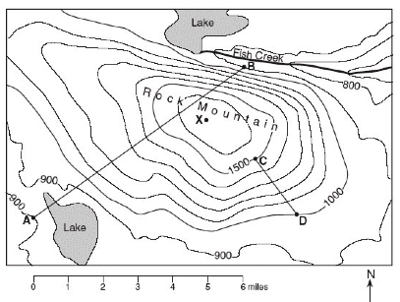6. Use the topographic map to answer the questions below.

a. What is the contour interval?

b. In what direction is Fish Creek flowing?

c. What is the highest possible elevation of point X?

d. What happens to elevation when you reach the lake?

e. Which side of Rock Mountain is the steepest?

f. Calculate gradient between point C and point D.

Construct a profile from point A to point B.