Earth Science Midterm Review

Unit 1: Maps and Measurements
- What are the pieces of evidence for the Big Bang Theory?
- What is an observation?
- What is an inference?
- A city in NYS has an altitude of Polaris to be 43.5°. What is the latitude of this city and what is the name of the city?

- How are latitude/longitude lines drawn the earth (equatorial view and polar view)?
- Determine the latitude and longitude of Ithaca.
- What is a topographic map? What does it show?
- What are hatchured lines?
- Use the map below to determine:
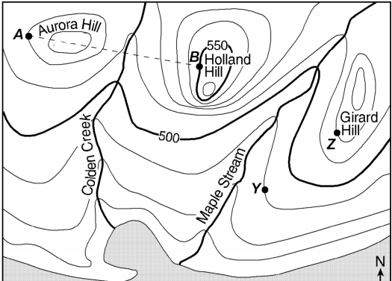

Direction of flow for Maple Stream:

Elevation of location Y:

The highest point on Holland Hill:

The contour interval:

Unit 2: Minerals and Rocks
- Identify a mineral that has non-metallic luster and can have the shape of little cubes.
- How do we determine luster, breakage, streak and hardness?
- What are the characteristics of an intrusive/extrusive igneous rock?
- How do the different types of sedimentary rocks form?
- What does the word monominerallic mean?
- Why goes gneiss have a distorted structure (think about how it forms…)?
- How are rock classified?
- What is the main idea of the rock cycle?

Unit 3: Dynamic Earth
- At a depth of 5000km, what it the temperature and pressure?
- What are the layers of the internal earth? Then determine their properties (density/ temperature/ composition).
- Why do convections currents occur?
- What are the pieces of evidence for the Theory of Continental Drift?
- What are the properties of p-waves and s-waves (travel speed, what parts of earth they travel through or not)?
- What causes a tsunami?
- How many seismic stations are needed to determine the epicenter?
- The seismogram below shows P-wave and S-wave arrival times at a seismic station following an earthquake.
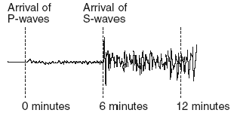
Determine the distance from this seismic station to the epicenter of the earthquake.

