1. Geologic history
- What pages in the ESRT do we use for geologic history?
- Why are index fossils a good time marker?

- Why is volcanic ash a good time marker?

- What is an unconformity?

- Which page in the ESRT provides information on radioactive decay?
- Carbon-14 dates living things while Uranium-238 dates old rocks

2. Earth Motions
- How was the universe formed and what are the two pieces of evidence?

- The earth rotates and revolves in which direction?

- How many degrees does the earth rotate in 1 day?

- How many degrees does the earth revolve in 1 day?

- To an observer in New York, stars appear to make a complete circle around __________________

3. Seasons
- Complete the table below with information regarding seasons:
Season
Date
Latitude that receives the direct ray
Direction of sunrise and sunset
Length of daylight in NY

4. The Solar System
- Which page in the ESRT has information on the solar system?

- What force caused planet, stars, asteroids, etc. to form?

- The closer a planet is to the sun, the higher its velocity and the further the planet is from the sun, the slower its velocity.

5. The Moon
- Why do we have tides?
- During which moon phase do we experience a solar eclipse? Describe what is happening

- During which moon phase do we experience a lunar eclipse? Describe what is happening

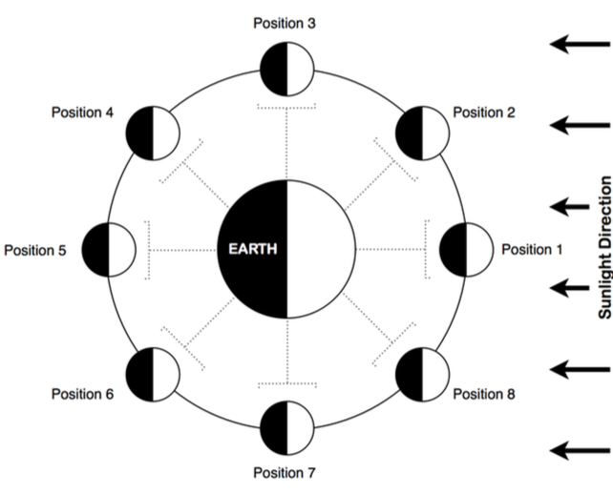
- Label each position of the moon and draw an image of what that phase looks like from Earth.

6. Stars
- Identify the nuclear process that combines lighter elements into heavier elements to produce the energy radiated by stars.

- How are stars classified?

- What color star is the hottest?

Regents Questions (Homework)

1. How old is a bone that has 12.5% of the original amount of radioactive carbon-14 remaining?

2. Which gas is inferred to have been absent from Earth’s atmosphere during the Early Archean Era?

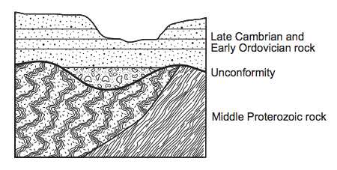
Base your answers to questions 3 and 4 on the cross section to the right. The unconformity is located at the boundary between Middle Proterozoic rock and Late Cambrian and Early Ordovician rock.

3. Identify one geologic process that occurred in this region that produced the unconformity in this outcrop.

4. Identify by name the oldest New York State index fossil that could be found in the Early Ordovician bedrock.

5. Determine the sequence of relative age from oldest to youngest.
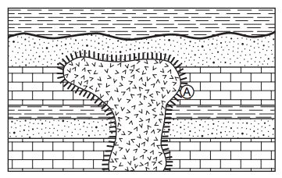
6. During the month of January, at which location in New York State is the Sun lowest in the sky at solar noon?
(1) Massena | (2) Niagara Falls | (3) Utica | (4) New York City

7. New York State bedrock of which age contains salt, gypsum, and hematite?
(1) Cambrian | (2) Devonian | (3) Mississippian | (4) Silurian

8. Which organisms were alive when New York State was last covered by a continental ice sheet?
(1) Eurypterus and Cooksonia | (3) mastodont and Beluga whale
(2) Aneurophyton and Naples Tree | (4) Coelophysis and Elliptocephala

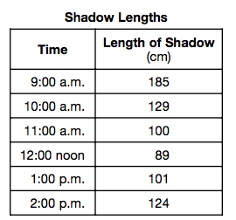
Base your answers to questions 9 through 11 on the data table below, which shows the length of a shadow, in centimeters, made by an object at different times during the day in New York State.

9. Predict the length of the object’s shadow at 2:30 p.m.

10. Explain what causes the length of the shadow to change during the day.

11. Toward which compass direction from the object does the shadow point at solar noon?

12. Which characteristic of the planets in our solar system increases as the distance from the Sun increases?
(1) equatorial diameter | (2) eccentricity of orbit | (3) period of rotation | (4) period of revolution
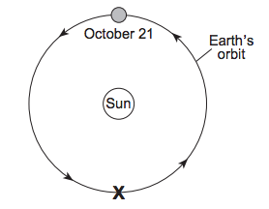
13. The diagram to the right represents the orbital position of Earth on October 21. Which Northern Hemisphere season is occurring when Earth reaches position X?

14. Why are high tides on Earth greatest when the Moon is in the full moon and new moon phases?
(1) The Moon is closer to the Sun. | (3) The Moon, the Sun, and Earth are aligned.
(2) The Moon is closer to Earth. | (4) The Moon is in the same phase at both locations.

15. Light from distant galaxies most likely shows a
(1) red shift, indicating that the universe is expanding | (2) red shift, indicating that the universe is contracting
(3) blue shift, indicating that the universe is expanding | (4) blue shift, indicating that the universe is contracting

16. Which characteristics best describe the star Betelgeuse?
(1) reddish orange with low luminosity and high surface temperature
(2) reddish orange with high luminosity and low surface temperature
(3) blue white with low luminosity and low surface temperature
(4) blue white with high luminosity and high surface temperature

17. The same side of the Moon always faces Earth because the Moon’s period of revolution
(1) is longer than the Moon’s period of rotation | (3) is longer than Earth’s period of rotation
(2) equals the Moon’s period of rotation | (4) equals Earth’s period of rotation

