1. Weathering
- Define weathering:

Physical/Mechanical Weathering | Chemical Weathering
Definition: | Definition:
Types: | Types:

- When a rock is broken into smaller pieces, surface area __________________ and weathering rate __________

2. The Water Cycle
- Label the water cycle

DRAW IN THE WATER CYCLE!!!!!!

- What factors determine if water will infiltrate into the ground or will runoff into the ocean?

3. Porosity, Permeability and Capillarity
- Define porosity:
- Porosity does not depend on particle size

- Define permeability:
- As particle size increases, permeability increases

- Define capillarity:
- Capillarity increases when particle size decreases

4. Erosion and Deposition
- Define erosion

- Define deposition

- GRAVITY is the force that drives erosion

5. Streams
- What is the shape of a valley made by a stream?
- Stream velocity depends on slope and discharge (amount of water)
- Describe where and why erosion/ deposition occur on the diagram below.

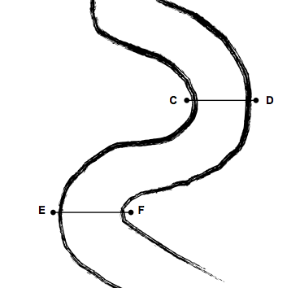

- Describe how streams deposit sediment

6. Glaciers
- What is the shape of a valley made by a glacier?
- What is a drumlin?
Direction of the glaciers movement is determined by the drumlin. It moves from the contour lines close together to the contour lines spread apart.

7. Mass Movements, Wind, Waves
- Describe how mass movements deposit sediment

- Describe how wind deposit sediment

- Describe how waves deposit sediment

8. Landscapes
- Arid landscape- steep slope with sharp angles
- Humid climate- smooth with rounded slope
- Stream drainage patterns that develop in a landscape region are determined by _________________________

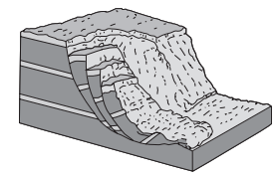
Regents Questions (Homework)

(1) groundwater and abrasion | (3) prevailing wind and abrasion
(2) groundwater and gravity | (4) prevailing wind and gravity
1. The block diagram to the right represents a rapid downslope flow of saturated soil and rock layers. What are two likely causes of this rapid downslope flow?

2. Which climate conditions most likely produce a landscape with rounded hills, large river valleys with many tributaries, and tropical vegetation?
(1) cool and arid | (2) cool and humid | (3) warm and arid | (4) warm and humid

3. Which agent of erosion most likely moves sediments in a sand dune? ______________________________________
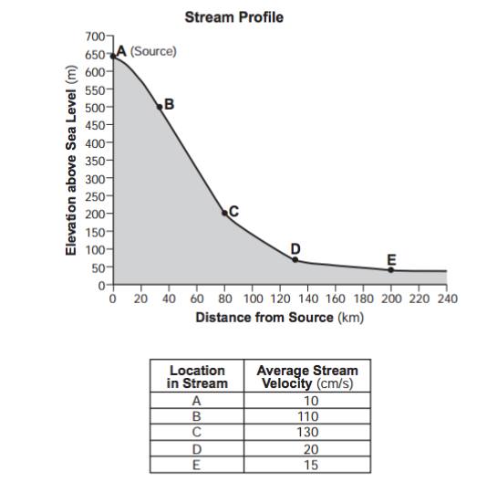

Base your answers for questions 4 through 6 on the diagram to the right.

4. The average stream velocity at each location is controlled primarily by the
(1) elevation above sea level
(2) sediment carried by the stream
(3) slope of the land
(4) distance from the stream’s source

5. What is the largest type of sediment that could be transported at location B? ______________________________

6. Which features could be formed by the stream between locations D and E?
(1) meanders (3) barrier islands
(2) kettle lakes (4) drumlins

7. After a heavy rainstorm, vegetation on a hillslope was completely removed. How will this removal of vegetation affect the relative amounts of infiltration and runoff that occur during the next heavy rainstorm?
(1) Infiltration and runoff will both be less.
(2) Infiltration and runoff will both be greater.
(3) Infiltration will be less and runoff will be greater.
(4) Infiltration will be greater and runoff will be less.

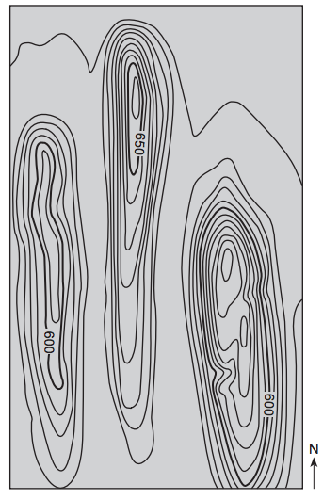
8. The topographic map to the right shows three drumlins located in New York State.

What was the direction of the advancing ice movement that created these drumlins, and what is the most likely arrangement of sediments in the drumlins?
(1) north to south ice movement, and unsorted sediments
(2) north to south ice movement, and sorted sediments
(3) south to north ice movement, and unsorted sediments
(4) south to north ice movement, and sorted sediments

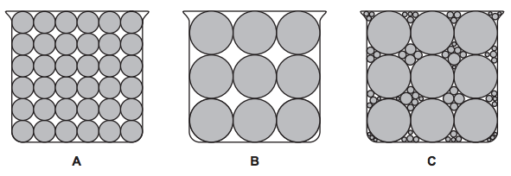
9. The diagram below represents cross sections of equal-size beakers A, B, and C filled with beads. Which statement best compares the porosity in the three beakers?

(1) Beaker A and beaker B have the same porosity, and beaker C has the least porosity.
(2) Beaker A and beaker B have the same porosity, and beaker C has the greatest porosity.
(3) Beaker B has the greatest porosity, beaker A has less porosity, and beaker C has the least porosity. (4) Beaker C has the greatest porosity, beaker B has less porosity, and beaker A has the least porosity.

10. When snow cover on the land melts, the water will most likely become surface runoff if the land surface is
(1) frozen | (2) porous | (3) grass covered | (4) unconsolidated gravel

