1. Density
- Density formula:

- Graph the relationship between pressure and density/ temperature and density:

- If a piece of a mineral is crushed into a million pieces, what happens to its density?

- Determine the mass of a rock that has a density of 2.5 grams/cm³ and a volume of 4.0 cm³

- A pebble has a mass of 35 grams and a volume of 14 cm³. What is its density?

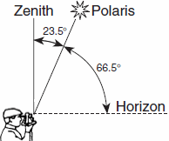
2. Polaris
- The altitude of Polaris equals your _________________________

- What is the latitude of the observer? ______________________

- Can you see Polaris in the Southern Hemisphere? ______________

- As your latitude increases, what happens to the altitude of Polaris?

3. Latitude and Longitude
- Latitude lines measure ________________ and ______________ of the equator and are drawn ____________________
The range for lines of latitude are ___________________ to _____________________.
- Longitude lines measure _________________ and ________________ of the Prime Meridian and are drawn ____________________. The range for lines of longitude are ___________________ to _____________________.
Location | Latitude | Longitude
A
B
C
D
E
F
- Time is based on observations of the Sun and longitude (15° of longitude = __________ hour)
- Use the diagram below to determine the latitude and longitude for each location. Don’t forget units.

4. Latitude and Longitude of New York
- Which page in the ESRT shows the latitude and longitude for different cities in New York State? _______
- In which hemispheres is NYS located? ___________________________________________
- Latitude Range for New York State: _______________________________________________
- Longitude Range for New York State: _____________________________________________
- How many minutes are in one degree? ____________________________________________
- Use the diagram below to determine the latitude and longitude for each location. Don’t forget units.
City | Latitude | Longitude
Syracuse
Elmira
Buffalo
Riverhead

5. Topographic Maps
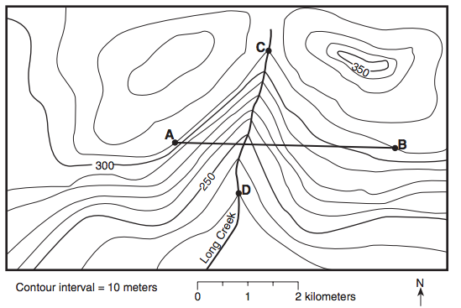

- Determine the contour interval: _____________________________
- What do hatchured lines represent? _________________________________________________
- What is the elevation of point A? _________________
- What is the highest possible elevation of point E? ____________________
- What is the lowest possible elevation of point F? _____________________
- Which side of the mountain has the steepest slope?

- What is the direction of stream flow? How do you know?

- How do the contour lines indicated the direction of stream flow?

- Calculate the gradient from C to D

Construct a topographic profile between points A and B

Things to remember…
- The shape of the Earth is an oblate spheroid (flattened sphere)
- Evidence for a round Earth and NOT a flat Earth are…a) Photographs of the Earth from space or the moon (this is the best evidence because it’s a direct observation). b) Earth's shadow seen on moon during eclipse. c) Ships disappear over horizon bottom first. d) Altitude of Polaris varies with latitude. e) Equal pull of gravity at locations on Earth’s surface
- The hydrosphere covers 70% of the Earth

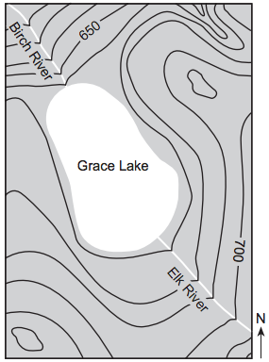
Regents Practice Questions:

1. Compared to the Elk River, the Birch River can best be described as flowing
(1) faster, and in the same general compass direction
(2) faster, and in the opposite general compass direction
(3) slower, and in the same general compass direction
(4) slower, and in the opposite general compass direction

2. The Genesee River in generally flows in which direction?

3. New York State’s highest peak, Mt. Marcy, is located at approximately
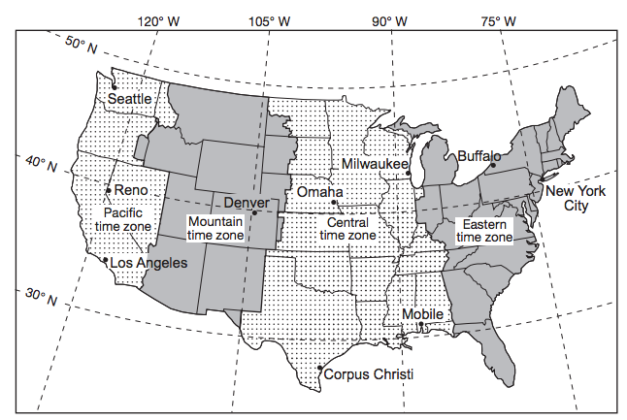  (1) 44°10 N 74°05 W | (2) 44°05 N 73°55 W | (3) 73°55 N 44°10 W | (4) 74°05 N 44°05 W

4. State the number of degrees of longitude that separates New York City from Reno, Nevada, and the time difference, in hours, between these two cities. ___________________________
5. Identify two cities on the map where measurements of the altitude of Polaris are within one degree of each other. ___________________________________________________________
6. Identify the city labeled on the map where sunrise occurs first each day. ___________________________________
7. Identify the Earth motion that provides the basis for our system of local time and time zones. ______________________
8. What are time zones based upon? _______________________________________________

